Ability Test Report

Name: Mr. Sample Candidate
Date: 19 January 2010






Ability Test Report
This Ability Test Report provides the scores from Mr. Sample Candidate’s Verify Ability Tests. If these tests were unsupervised, there is a small possibility that these scores do not represent his actual level of ability. A Verification Test is recommended to verify these scores. (See the following page for guidance.)

1 10 20 30 40 50 60 70 80 90 99
Percentile
31

Percentile compared to the
General Population 2007 comparison group
Inductive Reasoning

Level: Graduate/University
Language: UK English

Mr. Sample Candidate’s estimated inductive reasoning ability is average when compared to the comparison group. His result is better than 31% of the people in this group. This suggests that he will be as able as most to work with incomplete information to solve novel problems.

1 10 20 30 40 50 60 70 80 90 99
Percentile
59

Percentile compared to the
General Population 2006 comparison group
Numerical Reasoning

Level: Graduate/University
Language: UK English

Mr. Sample Candidate’s estimated numerical reasoning ability is average when compared to the comparison group. His result is better than 59% of the people in this group. This suggests that he will be as able as most to understand or interpret numerical data and mathematical calculations.

110203040506070809099

Percentile42
Percentile compared to the
General Population 2006 comparison group

Verbal Reasoning

Level: Graduate/University
Language: UK English

Mr. Sample Candidate’s estimated verbal reasoning ability is average when compared to the comparison group. His result is better than 42% of the people in this group. This suggests that he will be as able as most to understand and to evaluate written reports and documents.

If any of these tests were administered without supervision, a Verification Test is recommended to determine if those results can be used with confidence.

Guidelines for using these results
If the results in this report were obtained from tests completed without supervision, a Verification Test is recommended to confirm this individual’s test results.

The Verification Test is shorter than the original Ability Test. It must be administered in a supervised setting and will determine if the result of the Ability Test is Verified or Not Verified. A Verified result can be used with confidence.

How to verify a result
There are many ways to confirm an individual’s ability level. Some techniques are listed below:

Administer a Verification Test | Administering a supervised Verification Test is the most consistent way to verify the original test results. This is strongly recommended.
Consider information from other competency assessments | Use results from other assessments that relate to the competencies and/or skills important for performance in the job to evaluate the person’s actual ability level. For example, work simulations or assessment centers.
Use information from other sources | Results from examinations, qualifications, grades and other achievement tests that are appropriate measures of a person’s verbal and/or numerical ability may help to evaluate the person’s actual ability level.
Use structured interviewing techniques to probe related competencies | Competencies related to cognitive ability include:  - Presenting & Communicating Information  - Writing & Reporting  - Applying Expertise & Technology  - Analyzing  - Learning & Researching  - Creating & Innovating  - Formulating Strategies & Concepts

The final decision on how to confirm and use the person’s test results should follow internal policies and guidelines. Companies should evaluate the risks involved, corporate policy/governance, the use of other screening and selection tools, time, cost and other factors. All of these may be important when selecting the most appropriate method to verify an individual’s Ability Test results.

Information about this report

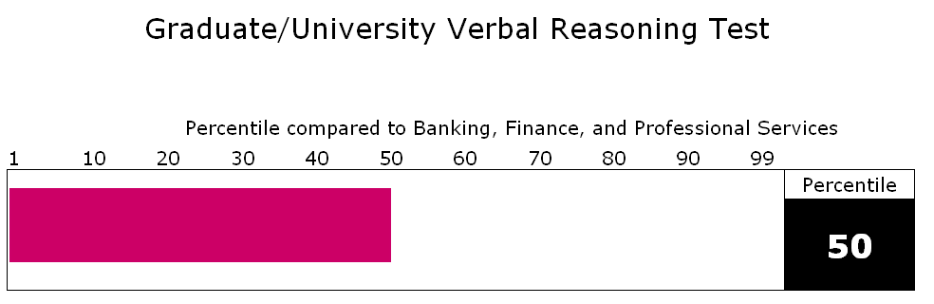
Type of Ability Test

Comparison group used

Percentile score from the Ability Test

The bar represents the Ability Test score

How to interpret this information
- The bar chart displays the individual’s percentile score from the Ability Test.
- The comparison group identifies the specific group of people composing the comparison group.
- The percentile score indicates how well this person scored against the people in the comparison group.
- For example, a percentile score of 50 means that the individual performed better than 50% of the people in the comparison group.

About cognitive ability tests
Cognitive ability (numerical, verbal and other forms of critical reasoning ability) is the most effective, single predictor of future performance in many different jobs. However, many other factors also play an important role in predicting job performance. The information in this document should be used as part of a broader evaluation to determine this person’s suitability and potential for the job.

About the inductive reasoning test
This test measures the ability to work with incomplete information to create solutions to novel problems. People who perform well on this test will have a greater capacity to think conceptually as well as analytically.

About the numerical reasoning test
This test measures the ability to make correct decisions or inferences from numerical data. The data presented and the tasks set are relevant to a business environment. The emphasis in these tasks is on understanding and evaluating data rather than on computation. People who perform well on this test tend to have the capacity to understand numerical data and interpret mathematical information correctly.

About the verbal reasoning test
This test measures the ability to evaluate the logic of various kinds of arguments. The information presented is relevant to a business environment. The test emphasizes understanding, using and evaluating verbal information rather than language usage, spelling or grammar. People who perform well on this test tend to have the capacity to readily understand reports and documents.

More Information
Additional information and guidance on how to use the SHL Verify range of Ability Tests is available online at www.shl.com.

Technical information
T-scores and Sten scores are provided for users who are trained in their appropriate use and interpretation.
A T-score is a standardized test score with a mean of 50 and a standard deviation of 10. The Sten score is a standardized score on a 10-point scale. It has a mean of 5.5 and a standard deviation of 2.
Name: Mr. Sample Candidate
Type of Test: Inductive Reasoning
Test Level: Graduate/University
Language: UK English
Comparison Group: General Population 2007

T-Score
20 25 30 35 40 45 50 55 60 65 70 75 80
1 | 2 | 3 | 4 | 5 | 6 | 7 | 8 | 9 | 10
Sten Score
T-score: 45
Sten score: 5

Name: Mr. Sample Candidate
Type of Test: Numerical Reasoning
Test Level: Graduate/University
Language: UK English
Comparison Group: General Population 2006

T-Score
20 25 30 35 40 45 50 55 60 65 70 75 80
1 | 2 | 3 | 4 | 5 | 6 | 7 | 8 | 9 | 10
Sten Score
T-score: 52
Sten score: 6

Name: Mr. Sample Candidate
Type of Test: Verbal Reasoning
Test Level: Graduate/University
Language: UK English
Comparison Group: General Population 2006

T-Score
20 25 30 35 40 45 50 55 60 65 70 75 80
1 | 2 | 3 | 4 | 5 | 6 | 7 | 8 | 9 | 10
Sten Score
T-score: 48
Sten score: 5

If any of these tests were administered without supervision, a Verification Test is recommended to determine if those results can be used with confidence.
PERSON DETAIL SECTION

Name | Mr. Sample Candidate
Date | 19 January 2010
 | 20490/ 12 / 1975

About this report

This report shows the result(s) obtained from ability test(s). The use of these tests is limited to those people who have received the necessary training in their use and interpretation.

The report herein is generated from the results of test(s) answered by the respondent. This report has been generated electronically - the user of the software can make amendments and additions to the text of the report.

SHL Group Limited and its associated companies cannot guarantee that the contents of this report have not been changed since it was output by the computer system. We can accept no liability for the consequences of the use of this report and this includes liability of any kind (including negligence) for its contents.

Ability Test Report Version Number: 1.1 (beta)
www.shl.com

© SHL Group Limited 2008. All rights reserved. SHL is a trademark of SHL Group Limited which is registered in the United Kingdom and in other countries.

This report has been produced by SHL for the benefit of its client and contains SHL intellectual property. As such, SHL permits its client to reproduce, distribute, amend and store this report for its internal and non-commercial use only. All other rights of SHL are reserved.

